

**Avalanche Innovation Team:**

Nishan Subba - Database Administrator

Aman Gurung - Data/Business Analyst I

Chiagoziem Igwe - Data/Business Analyst II

Dhulfiqar Hussein - Lead Developer I, Full Stack

Harshitha Sayini - Developer II, Full Stack

Trevin Nisbett - Project Manager, Quality Assurance

Professor: Shiva Sharma - IS436 Structured Systems Analysis and Design

Date: Dec 10, 2023

Deliverable Name: Project Deliverable - Final Project Submission

# Final Project Submission

**Final Project Submission 2**

**GitHub 3**

Kanban Board 3

Project Repository 3

**Project User Guide Documentation 3**

**Live Demo 3**

Updated Site Map 3

**Team Member Information 4**

Trevin Nisbett - Project Manager, Quality Assurance 4

Dhulfiqar Hussein - Lead Developer I, Full Stack 4

Harshitha Sayini - Developer II, Full Stack 5

Nishan Subba - Database Administrator 5

Aman Gurung - Data/Business Analyst I 5

Chiagoziem Igwe - Data/Business Analyst II 5

**Meeting Time 6**

Contact US 6

# GitHub

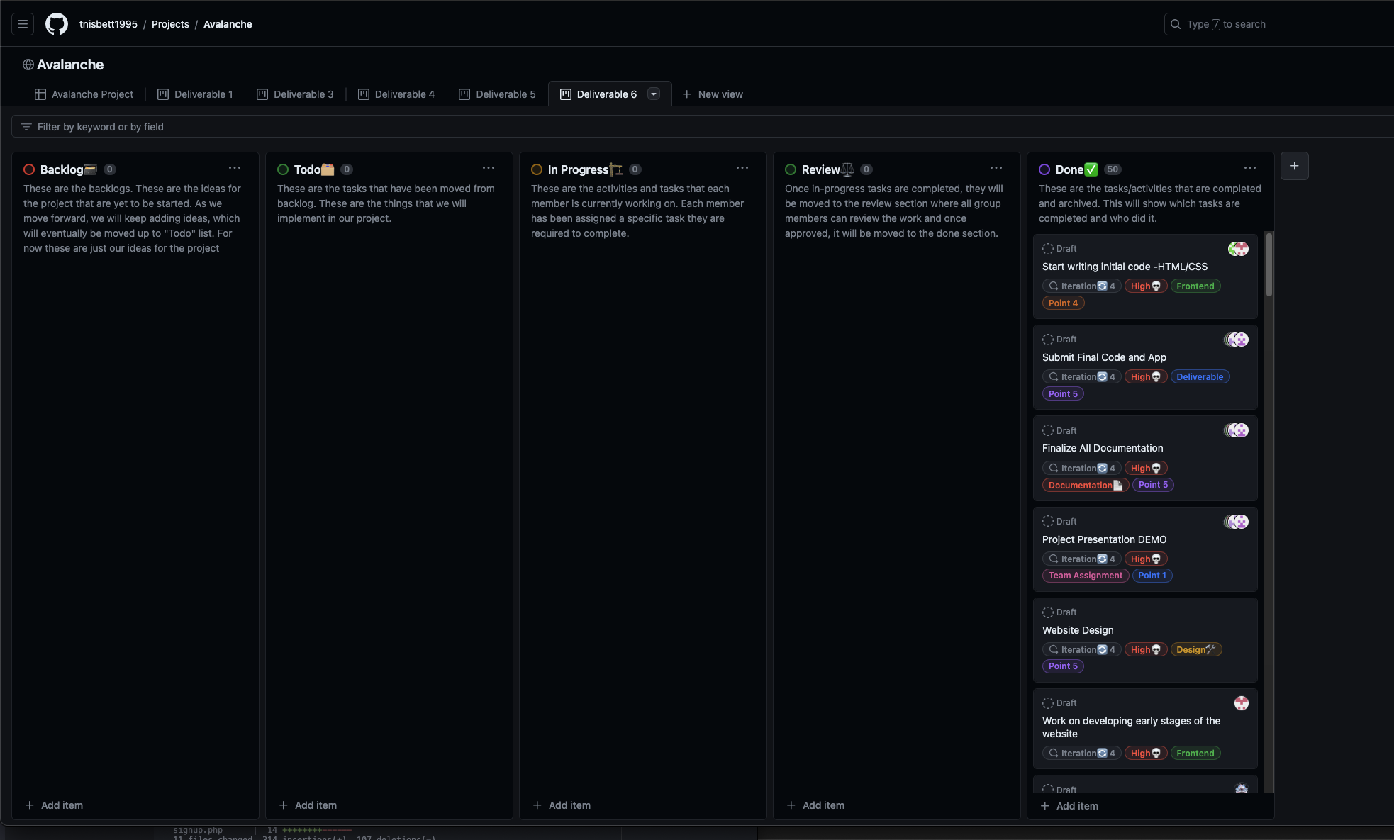

## Kanban Board

Link: <https://github.com/users/tnisbett1995/projects/3/views/12>

## Project Repository

Link: <https://github.com/tnisbett1995/IS-436-Group-7-Project>

# Project User Guide Documentation

Link: <https://github.com/tnisbett1995/IS-436-Group-7-Project>

# Live Demo

Link: <https://swe.umbc.edu/~nsubba1/prototypev9/PayrollSystem/dropdown.php>

## Updated Site Map

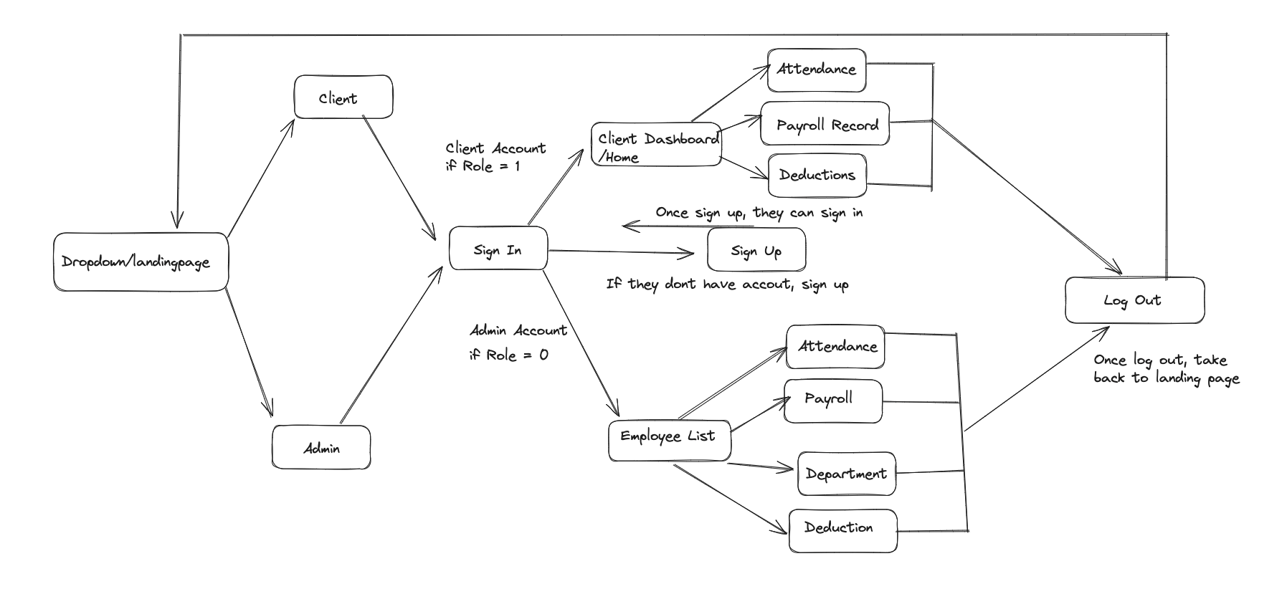

# Team Member Information

## Trevin Nisbett - Project Manager, Quality Assurance

I am Trevin Nisbett, and I will be the Project Manager for this project. I have experience in Java, SQL, and Excel. I am excited to work on this project and apply my technical skills to the Avalanche Innovation team to have a successful digital payroll system.

For questions or inquiries, please contact me at

Email: [tnisbet1@umbc.edu](mailto:tnisbet1@umbc.edu)

Github: tnisbett1995

## Dhulfiqar Hussein - Lead Developer I, Full Stack

Hello, My name is Dhulfiqar Hussein and I will serve as a full-stack lead developer alongside Harshitha. I have experience in the following areas, SQL, HTML, CSS, JAVASCRIPT, Python, C++, and PHP. I am excited to collaborate with the team and share my technical skills to drive the success of our digital payroll system project.

For questions or inquiries, please contact me at

Email: [dhussei1@umbc.edu](mailto:dhussei1@umbc.edu)

Github: DhulfiqarH

## Harshitha Sayini - Developer II, Full Stack

I am Harshitha Sayini and I will serve as a full-stack developer alongside Dhulfiqar. I have experience working with SQL, HTML, Java, CSS Javascript, and Excel. I will be using my programming skills to aid in the development of our web application for Avalanche Innovation. As a team, we will be committed to creating an application that will be accessible to all users.

For questions or inquiries, please contact me at

Email: [hsayini1@umbc.edu](mailto:hsayini1@umbc.edu)

Github: hsayini7078

## Nishan Subba - Database Administrator

I'm Nishan, and I serve as the Database Administrator for our project. With a strong background in data management and experience in SQL, Python, and Excel, I've had the privilege of working with various databases, including Oracle and MySQL. My passion lies in extracting stories from data and transforming raw information into actionable insights. I'm committed to bringing my data expertise to the Avalanche Innovation team to ensure the success of our digital payroll system project.

For questions or inquiries, please contact me at

Email: [nsubba1@umbc.edu](mailto:nsubba1@umbc.edu)

Github: nissubba1

## Aman Gurung - Data/Business Analyst I

My name is Aman and I will serve as a Data/Business Analyst I for this project. I have experience in SQL, Statistics in Business and Econ, Excel, and Python. I am skilled in producing insightful data visualizations and reports that provide our company with the information they need to make wise decisions.

For questions or inquiries, please contact me at

Email: [amang2@umbc.edu](mailto:amang2@umbc.edu)

Github: Aman440501

## Chiagoziem Igwe - Data/Business Analyst II

My name is Chiagoziem Igwe, and I will serve as a Data and Business Analyst II for this project.

For questions or inquiries, please contact me at

Email: [chiagoi1@umbc.edu](mailto:chiagoi1@umbc.edu)

Github: chiaigwe

# Meeting Time

Weekly Meeting:

Every Sunday @ 8 PM

## Contact US

For any inquiries or additional information related to this proposal, please get in touch with our key project members:

Trevin Nisbett

*Project Manager, Quality Assurance*

Email: [tnisbet1@umbc.edu](mailto:tnisbet1@umbc.edu)

As the Project Manager, Trevin oversees the entire project, ensuring milestones are met, quality is maintained, and all team members collaborate effectively. For any project/proposal inquiry, Trevin is your go-to contact.

Aman Gurung

*Data/Business Analyst I*

Email: [amang2@umbc.edu](mailto:amang2@umbc.edu)

Aman, our Data/Business Analyst I, dives deep into the specifics of the payroll system, ensuring that the proposal aligns perfectly with the business requirements of the Gorilla Distribution Center. For details on the project’s analytical aspects, Aman is your go-to contact.